Date: 28th January 2025 at 7.00pm | Venue: Gordon Village Hall
Present:, Gail Wishart (Chairman), Bruce Brown (Secretary), Grace Donaldson (Treasurer), Ross Jones, John Purves, Douglas Tweedie, John Tyson, Jane Henderson
Apologies: Douglas Tweedie
In Attendance: Councillor Moffat, Eric Ravaglia, Jonathan Clogstoun-Wilmott

Chairman GW convened the monthly meeting, welcomed and thanked all for their attendance. Councillor Rowley’s lack of attendance and input over the last couple of years was discussed
MINUTES OF LAST MEETING
The minutes of the meeting of 26th November had been read by all; approved by GD and seconded by RJ.
GORDON ISSUES
Positioning of Speed Indicator Signs
Latest correspondence from Karen MacGrath (28th) regarding the positioning of the new signs was discussed. The siting of the west approach camera is still under question as residents had objected to original proposal. GW to respond and suggest site meeting to finalise position.
Gordon Church Sustainability
BB stated that with the imminent linkage of Earlston, Legerwood, Gordon and Greenlaw the charge of minister would be advertised. The main problem with advertising the position as there is currently no manse in Earlston; the planning application for the new manse has yet to be approved by SBC planning. No other suitable house for sale had been identified. The annual “Giving to Grow” contribution by St Michael’s to the Church of Scotland was to increase to around £6,500. This was considered excessive given the lack of support from 121 george Street. Remedial electrical works (c£5,000) were to commence on Monday 2nd Feb to achieve EICR certification.
Village Hall Main hall closed until further notice due to ceiling/fabric issues.
Garages in Glege Park
Concern had been raised about the dilapidated condition of the 12 BHA garages in Glebe Park. JH reported that BHA (Katie Cockburn) had replied that were no vacant garages for let. Rent is £11.56/week. Repairs to flashings and some repainting was required.
Gordon Sports Field
Nothing to report. Tennis court excavation; grateful thanks to Chisholm Groundworks for a neat job.
Playpark: JH expressed disappointed that cycleway had been relaid using tarmacadam with sharp edges instead of the rubberised compound. SBC replied the surface is extremely smooth and suitable for young people to be able to develop cycling and wheeling skills. No renovation for playpark equipment as SBC has pulled the budget for playparks.

WESTRUTHER ISSUES
Berwickshire Housing Association Demolition of Edgar Road Houses
JP reported that BHA had asked him to agree for them to put in an application (26/00116/HON) to demolish his house but no agreement had been fully concluded. Cruden had been on site to assess demolition project.
GD stated there would reportedly be building 2,3 and 4 bedroom houses and 6 bungalows on the site around 2027-29. By whom it was yet to be confirmed. Project had been identified on SBC SHIP. Discussion ensued regarding the suitability of Westruther for more affordable housing given the lack of transport links, employment opportunities and community facilities. Eric Ravaglia expressed his concerns regarding effects to his neighbouring property. It was unanimously agreed that CC’s should have more say in all proposed developments in their areas and community plans.

Eildon Development of 10 Affordable Homes in Edgar Road and Edgar Court
All houses were not occupied. The ongoing cost of council tax and electricity charges for these ‘affordable’ homes was discussed.

Westruther Primary School There has been some concern regarding the loss of the headmistress without prior notice, consultation with parents nor justification. The new headmaster would cover Lauder and Westruther. The headmistress would now cover Gordon and Channelkirk instead. Further discussion took place around Westruther school sustainability and the general lack of support for rural schools. Without good schools, villages lose their appeal for young families. Nurseries and playgroups aid social cohesion and community growth.

Old Church A proposal from Berwickshire Civic Society was discussed as to whether doing some renovation work to make it safe and accessible to the general public. There were funds to do the work but thereafter who would maintain the church? GW proposed it should be discussed by the village hall committee; possibly for them to take custodianship. The ruined structure would be coped and pointed.
Community Council do not have the resources to undertake responsibility.

Renewable (Wind, Solar, BESS) Developments
GW reported on her attendance at the Community Council convention on the impact on Communities of Major Energy Infrastructure in the Scottish Borders held on in Jedburgh Town Hall. Excessive constraint payments paid to wind farms for NOT producing electricity. As per subsequent email from Leitholm CC, the Unified Statement prepared by Highland CC’s was discussed as to whether we would be willing to sign up to it. The unified statement reads:

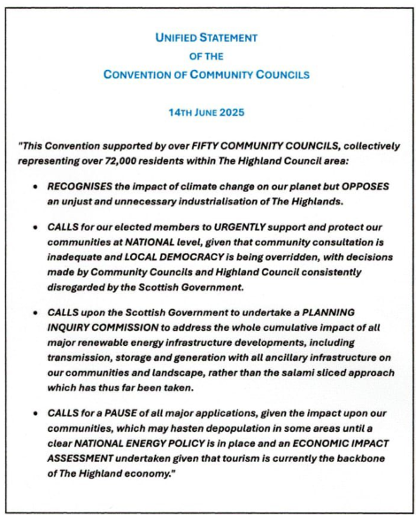

It was decided that GWCC members read and consider the statement and confirm to the Secretary their agreement for us to write to Leitholm CC to ratify our support for the statement. It was universally thought that individual elected councillors should be asked whether they support it. Basically if all developments were approved Scotland would be generating 1.5 to 2 times the power required for the whole of Scotland WITH NO BENEFIT TO LOCAL OR NATIONAL ECONOMIES.
It was also discussed how abhorrent it was that SBC would not oppose renewable projects especially those on prime agricultural land rather than brownfield sites. There is a meeting in Holyrood with the SG to discuss energy policy. Data centres planned for Coldstream and Longformacus were discussed as to the large amount of power and how environmentally unfriendly they are. They are also required (in addition to CCTV’s and 5G infrastructure) purely to increase future surveillance and control of the general population.
JP remarked as to the large number of windfarms offshore and still not connected to the grid onshore.
As regards renewable developments, National Planning Framework 4 was no longer fit for purpose. The recent climbdown by the WEF at Davos on climate action was noted due to the detrimental impact on western nations’ industrial bases.

PUBLIC CONSULTATION The Draft “Culture, Arts and Heritage Strategy for the Scottish Borders” was reviewed by some members as requested by Naomi Sweeney. It was generally found to be exhaustive, boring and poorly authored. Secretary to respond officially to NS. In essence, it was regarded as a complete waste of public money. It did not even define what our culture is.
JP will review the Scottish Water consultation Safeguarding Scotland’s Water by 3rd March 2026.

PLANNING
26/00017/VAA Vehicle Access Application 20 Murrayfield Gordon. No comments or objections forthcoming.

Police Reports
Nothing of note for our area other than a minor disturbance at Flass Farm. Break-in at Wedderlie House (machinery and items stolen).
Any queries/information may be addressed to midberwickshireCPT@scotland.pnn.police.uk.

Councillors Reports
DM reported complaint from \Gordon resident regarding installation of lamp standard immediately after road had been resurfaced. Better planning required.

AOCB
Grateful thanks to Alex Watson for her initiative in personally litter picking the Kelso road from Byrewalls junction into the village amassing three full sacks of rubbish. Well done Alex for your community spirit!
The Borders Tree Grant Scheme was discussed as to whether there were any local areas which would benefit from this.

Date of Next Meeting: Next meeting will be Wednesday 25th February 2026 at 7pm in WESTRUTHER VILLAGE HALL. (NOTE: All CC meetings are held on the last Wednesday of each month)

